Intro to Programming (Python)

Assignment 03

# Overview

In this activity, you learn about typical programming statements and working writing to a file. You also learn about how to download, install, and use a new Integrated Development Environment (IDE) called PyCharm. Once again, you create an assignment script and document your knowledge. In later modules, your documents will be reviewed by your peers, so practice making your document and code look professional!

This assignment includes the following tasks:

1. Watch the module videos.
2. Read a book chapter.
3. Review some web pages.
4. Watch the additional videos.
5. Apply your knowledge.
6. Document your knowledge.
7. Submit your work.

**Tip:** Consider the following questions while you work through the module to help you focus:

* What is pseudo-code?
* What are "conditional" statements?
* How do you use multiple conditional expressions?
* What are comparison operators?
* What are the Boolean values for the integers 0, 1, and 2?
* What is a Loop?
* Name the most common programming loop?
* How do you pass arguments into a script?
* What statement allows you to write data into a file?

# Assignment Steps

The following assignment steps ask you to read about, perform, and write about programming.

***Note:*** *Course assignments help you learn through* ***reading****,* ***watching*** *demonstrations,* ***performing*** *programming in Python, and reflecting on what you learned through* ***writing****. You are strongly encouraged to continue your learning by experimentation.*

## Step 1 - Watch my Video Lecture

Please watch my course lecture for this module. You can find this module lecture(s) here: [ITFdn 110 - Python Course Videos](https://youtube.com/playlist?list=PLfycUyp06LG9fZllIqBrxLcNV4CR50HEX)

Please watch these additional videos as well:

## Step 2 - Read a book chapter

Please **read chapter three** in your textbook. You **do not have to perform the exercises or type in the code**, but it is best if you open the script files as you read about them. You can find the downloadable **book files** **on Canvas** for your convenience.

## Step 3 - Web pages

Please review the following web pages. These are shorter than the book and provide online resources you can use later.

1. <http://www.tutorialspoint.com/python/python_if_else.htm> (external site)
2. <http://www.tutorialspoint.com/python/python_while_loop.htm> (external site)
3. <https://www.applause.com/blog/functional-testing-types-examples> (external site)

## Step 4 - Additional Videos

Please watch this video. It will explain things a bit differently, which helps with learning!

1. [Python Programming Tutorial - 20 - If Statement](https://youtu.be/II5WTVvryvk) (external site)
2. [Python Programming Tutorial - 21 - else and elseif](https://youtu.be/g1maz1ynR74) (external site)
3. [Python Programming Tutorial - 22 - Nesting Statements](https://youtu.be/_HJTN1JRgC8) (external site)
4. [Python Programming Tutorial - 23 - Comparison Operators](https://youtu.be/E-s9sXB0XwY) (external site)

## Step 5 - Apply your knowledge

Now that you have reviewed the websites and videos, create a new program that asks the user for the name of a household item, and then asks for its estimated value. Store, both pieces of data in a text file called, HomeInventory.txt

### Step 5.1 Create a Folder

Create a **new sub-folder** **called Assignment03** inside of the **_PythonClass** **folder** (you created this in Module 01). Please use the C: Drive on a Windows OS or the Documents folder on a Mac OS (using the Desktop on either OS is not recommend).

### Step 5.2 Create a new Project in PyCharm

Create a new project in PyCharm that uses the _PythonClass\Assignment03 folder as its location (figure1).

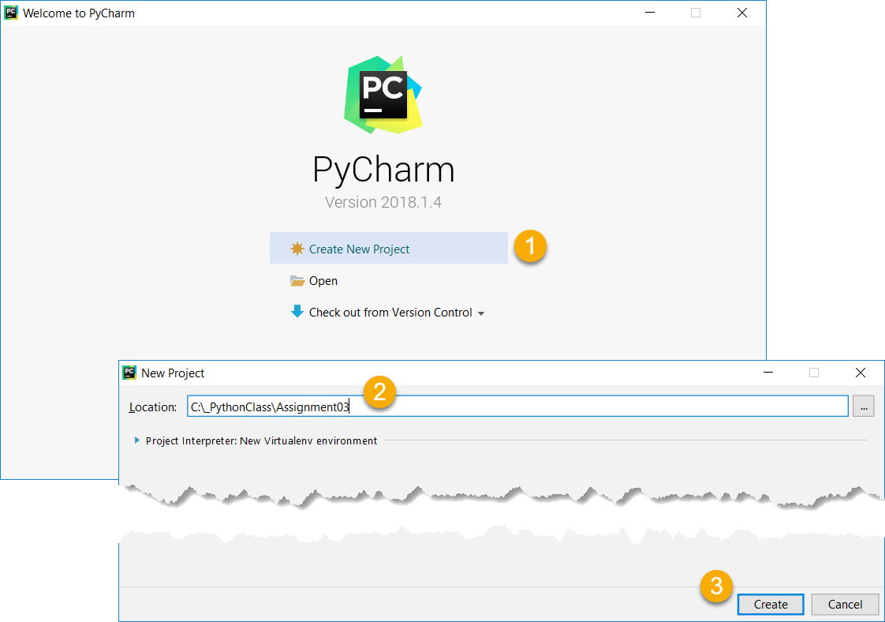

Figure 1: Creating a new project in PyCharm

### Step 5.3 Create a Python Script

Create a python script file within your project (Figure 2).

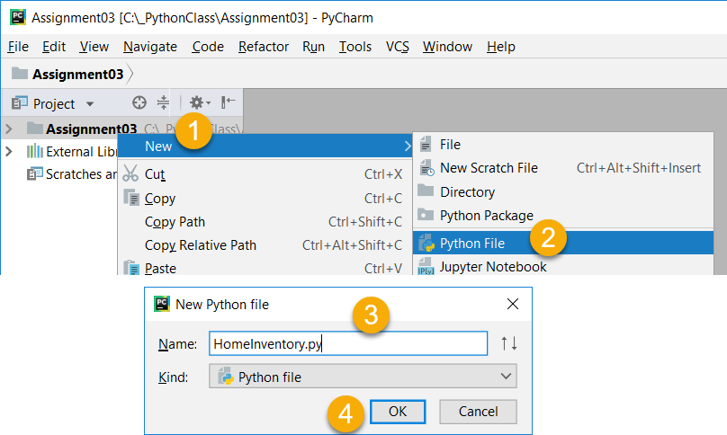

Figure 2: Creating a new Python Script in the Project

### Step 5.3 Add Code to the Script

Add code to your script that will perform that assignment’s task. I suggest you start by adding the header and some basic comments about what you are going to do (Figure 3).

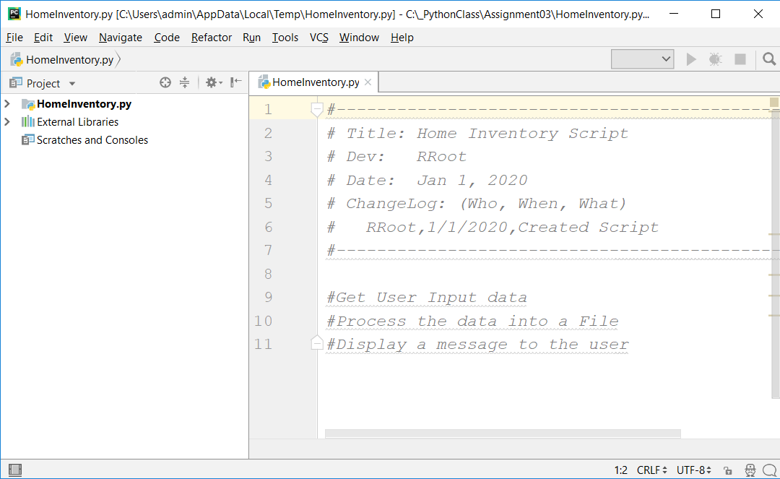

Figure 3: The start of code in HomeInventory.py

### Step 5.4 Run Your Script

With the script created in its proper location, run the script in **BOTH** PyCharm and an OS command/shell window and capture images of it working on your computer (Figures 4 and 5).

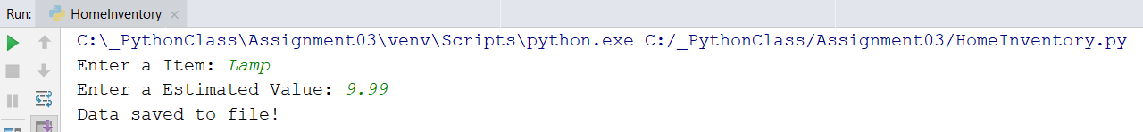

Figure 4: A screenshot of the script running in PyCharm.

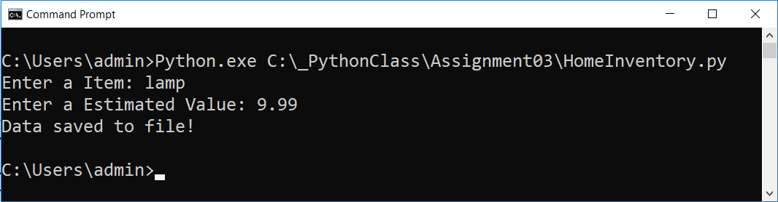

Figure 5: A screenshot of the script running in a command window.

### Step 5.5 Verify that it Worked

Locate the text file and open it in a text editor (Figure 6).

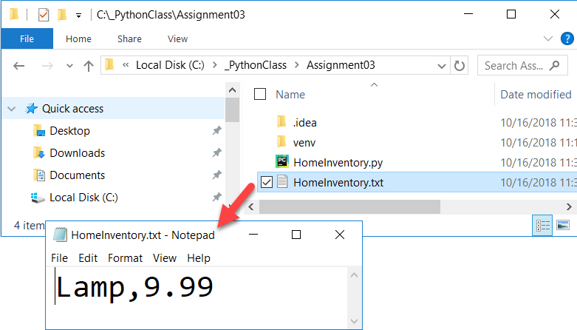

Figure 6: Verifying that the file has data

## Step 6 - Document your knowledge

After you have created and tested your Python script, create a document describing the steps you took in performing this assignment. Use screenshots and code samples to explain the process, just as was done in your book, my programming notes, and the web pages you reviewed.

**Notes:**

* All resources for this assignment are found in the lectures, recommended reading, or recordings specified in the class syllabus. You do not need to locate additional resources outside of these.
* Your document **must look professional** to get full points! Use my example template and video, in the General Files and Topics module, as a guide for what I expect a professional paper to look like. Make sure you format it like a college paper instead of a text message. Things like your **name, date, class, citations, introductory and summary paragraphs** are always expected! So, not putting these in the document will cost you! ([*See this video for help*](https://youtu.be/9ojhSW9ljjo)!)
* Please **save** your files as a PDF file called **Assignment03_YourNameHere.pdf.** Here is an example from Google Docs, but it is similar in most text editors!

**Important**: Make sure to include an introduction and summary, as well as a heading. It does not have to be perfect, but you won't get credit for it if you turn in a simple blob of text! watch this video to help you understand what I am looking for: [Creating Professional Documents](https://youtu.be/9ojhSW9ljjo)

## Step 7 - Submit your work

Now place your document with the python script in the Assignment03 folder. Zip this folder into a “.zip” file, then upload the file to the class assignment page.

Congratulations! You are done!